Rational comparison of field strength between semi-anechoic chamber and fully anechoic chamber
Ruoting Chang
The State Radio Monitoring Center(SRMC) ,China
No.80 Beilishi Road Xicheng District ,Beijing P.C 100037
e-mail :changrt@srrc.org.cn

Abstract:
In article the Validation of fully anechoic chamber adopted to perform EMI compliance test is explored by conducting test and theoretical analysis, an preferred limit which is correlated to the present limit based on OATS is provided.

Key words
open-area test sites (OATS), semi-anechoic chamber (SAC), fully anechoic Chamber (FAC), normalized sit attenuation (NSA).
1. Introduction:
The primary intention of emissions specifications is to prevent unwanted interference to radio services, and it is also the key measure for making sure spectra effectiveness. OATS is adopted as standard test site for radiated emission test would provide a controlled environment that not only simulated read ground reflection but also greatly enhanced the repeatability of measurements. With more and more numbers wireless devices and other apparatus, the presence of strong and complicated background noise resultant un-corrected errors of the test
results in OATS. As an alternative, semi-anechoic chambers have been installed world-wide in recent years. But SAC is very expensive. The relative large deviation of comparison results among different EMC labs indicates the inherent problems of SAC, and as a result, FAC are getting more attention. the correlation between FAC and SAC have to be determined for validating he use of FAC for certification to existing SAC limits. This article verifies this correlation values with comparison tests. FAC should play more important role for field strength test as well as radiated power test.

2. The fundaments and problems of SAC
Both NSA test and field strength test in SAC are based on the below geometrical optics model (Figure 1)
Transmit Receive
Antenna Antenna
direct ray

reflected ray
Ht Hr
ground plane

Figure 1
E=E_{O}(1+Γe^{jφ}) (equation 1)
Where: E=the resultant field
strength
E_{o}=the direct ray field
strength
Γ=reflect factor
φ=phase difference result from direct ray and reflected ray
The difference phase relation of these two rays make an interference pattern which corresponds to the function of the height of the receive antenna above the ground. The resulting effect rays from obliteration to almost doubling of the direct ray. So in the relevant standards, the receive antenna should scan the height among 1 to 4 meters. So as to locate the maximum strength. There are following known problems related to this methodology.
1). According to equation 1, the interference pattern depends on the distance between transmit and receive antenna, height of transmit antenna, polarization, frequency and type of antenna. In horizontal polarization, because of Γ= -1, and the distance difference between direct and reflected ray can not reach half wavelength or more below 100MHz, so constructive interference of direct and ground reflected signal can’t be found in the 1 to 4 m height scan range. Therefore the same magnitude of radiated emission will give a different reading in the received field strength for horizontal and vertical polarization on OATS (15dB at 10m distance, 0.8m source height). So the horizontal polarization radiation is underestimated strongly, at same time, in real world, the reflect factor of ground is never -1, so there is big risk to evaluate the potential interference of horizontal radiated emissions to radio reception according to present standards.
The height of maximum field strength of horizontal polarization and illustrated in below table. (10disiance, scan height 1 to 4m, transmit height 0.8m).
frequency (MHz) | maximum (location (m))
30-230 | 4
240 | 3.931
250 | 3.777
300 | 3.150
350 | 2.699
400 | 2.361
450 | 2.097
500 | 1.88689
950-1000 | 1.00
2).The variation in antenna factor with height of receive antenna, for horizontal polarization in low frequency band up to 2dB.
3).The variation in distance to EUT caused by varying phase center with frequency of log-periodic array antenna, the error result from this factor is unavoidable and un-corrected in OATS or SAC.
4).The error budget of site imperfect of SAC or OATS is 1dB, actually, because of relative amplitude accuracy of receiver or analyzer is very high and precise calibrated, antenna, the error results from test equipment can below 0.5dB. For most 10m SACS, deviation of NSA is around 3.5dB below 60MHz, so the error budget of site imperfect in relevant CISPR standard is unpractical the large deviation of comparison tests among different labs is nature.
5).The huge test time because of the scan receive antenna height for different polarization, scan and sweep, so test flexibility is impossible. Normally the above problems are not present or can be resolved in SAC.
The cost of 5m or 3m FAC is great lower than that of 10m SAC. In FAC, because of near-field effect, differences in theoretical NSA related to a frequency of 30MHz to far field condition of 3m and 5m are 1.1dB and 0.4dB respectively at 30MHz. it is acceptable.

3. Test Comparison between FAC and SAC
A simple relation can be established for perfect, ideal cases (which means free space, far field conditions) between E (v/m), distance between transmitting an antenna and the point of measurement (m), e.i.r.p (w).
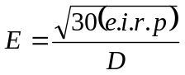 (Equation 2)
A maximum value of E can be calculated, representing the maximum reading obtainable on an OATS by adjustment of the measurement antenna height. It is
Emax≌1.6E, This means a site gain of 4dB.
For the free space condition without consideration of near-field effect, test field strength of 3m and 5m will 6dB and 1dB larger compared with the situation of 10m SAC respectively. The comparison tests have been conducted in SRMC 10 SAC, 5m FAC and 3m FAC to verify those value. Height of transmit antenna is 0.8m, height range of receive antenna is 1 to 4m, in additional, below 100MHz of horizontal polarization, receive antenna height was adjusted among 1 to 6m for locating the first peak point.
The deviations of NSA of 10m SAC, 3m FAC, 5m FAC are as below figures:
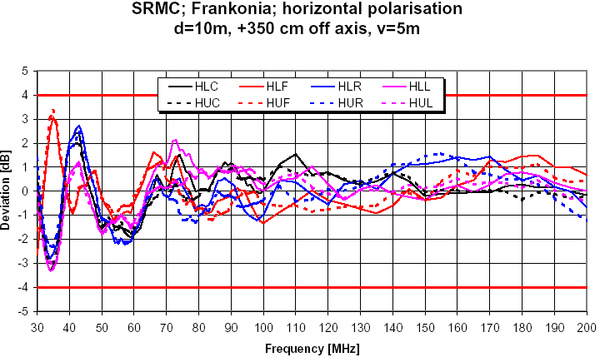
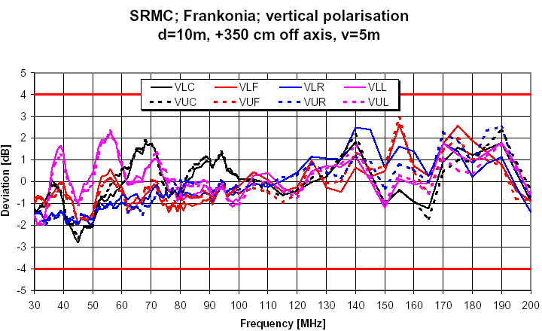
Figure 2 10m SAC
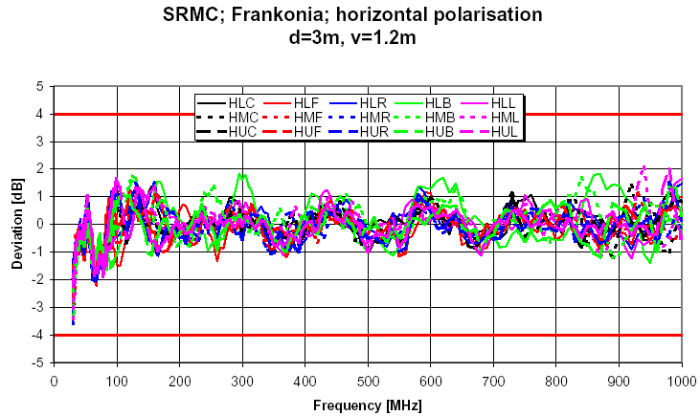
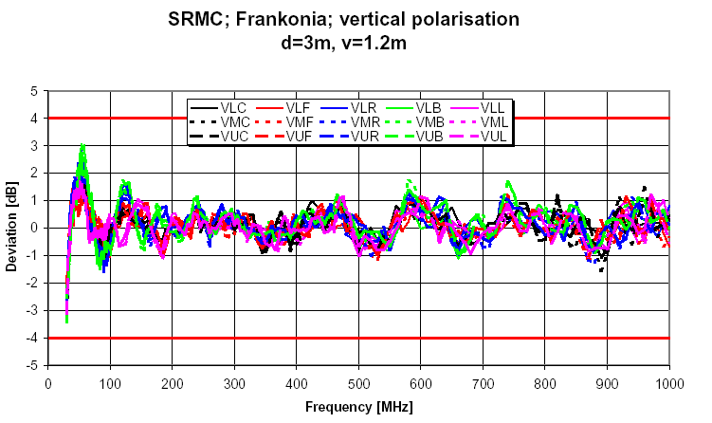
Figure 3 3m FAC

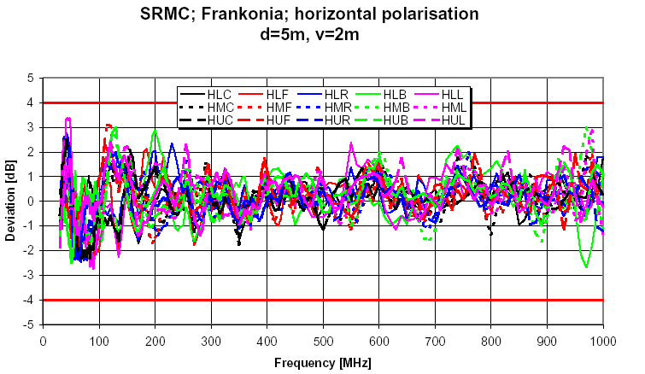
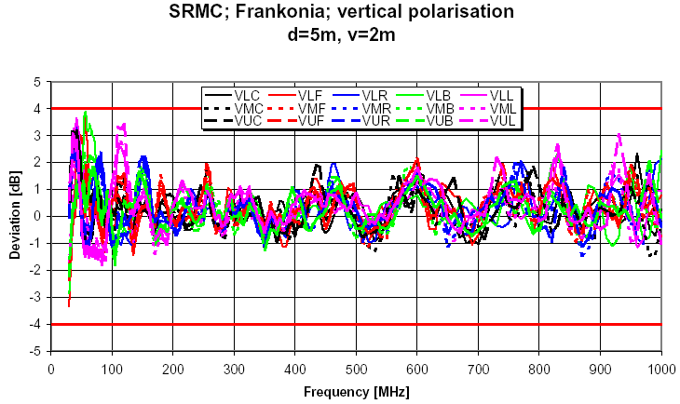
Figure 5 5m FAC
The comparison test results are as below:
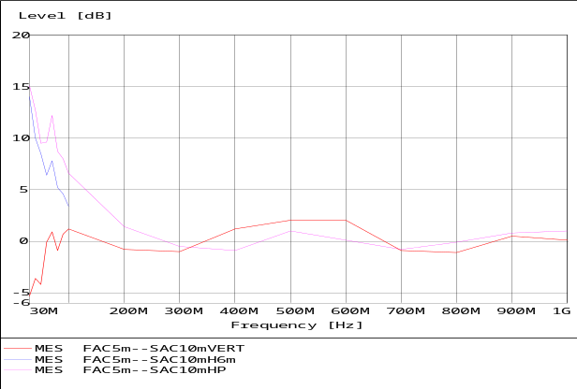
Figure 5 Comparison between 10m SAC and 5m FAC
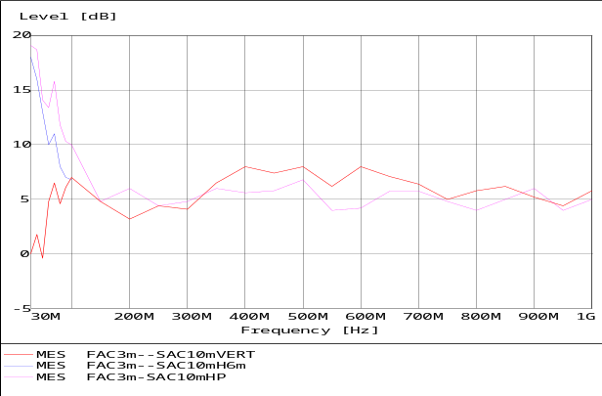
Figure 6 Comparison between 10m SAC and 3m FAC

The above figures show:
1. The deviation between theoretical and test results of vertical polarization of f≥60MHz is within ±2dB.
2. For horizontal polarization the theoretical test values of 5m FAC and 3m FAC are 10 dB and 15 dB larger compared with in 10m SAC at 30MHz respectively. The actual test results are 14dB and 18dB (receive antenna height from 1 to 6m). Above 150MHz, the deviation from theoretical value is within ±2dB.
When transmit antenna are 1.0m and 1.2m, the same tests were also carried out in SRMC, final results are almost same.
Comments on larger deviation below 60MHz:
The expand uncertainty of SAC and FAC facilitates of SRMC are as follows:
For 5mFAC, the expand uncertainty is 3.5dB (f≤60MHz)
For 3mFAC, the expand uncertainty is 3.2dB (f≤60MHz)
For 10mFAC, the expand uncertainty are 3.6dB (f≤60MHz,horizontal polarization)
and 3.4dB (f≤60MHz,vertical polarization).
So the larger deviations of comparison tests compared with theoretical values below 60MHz are reasonable.
4. Conclusion:
The advantages of FAC compared with SAC are obvious , both theoretical analysis and comparison tests shows the strong correlation of field strength test between FAC and SAC, especially, adopting FAC provide the objective estimation of horizontal polarization field strength. The preferred limits in FAC given in following table can achieve the same compatibility levels for electromagnetic interference as class B (level) and class A (level 2) in CISPR 11 and CISPR 22.

measurement  distance (m) | Class B |  | Class A
measurement  distance (m) | Level1  (dBμv/m)  30-230MHz | Level1  (dBμv/m)  230-1000MHz | Level2  (dBμv/m)  30-230MHz | Level2  (dBμv/m)  230-1000MHz
3 | 36 | 43 | 46 | 53
5 | 31 | 38 | 41 | 48
5. References
- Technical Report EN 50147—3:2001
- Dr.Gam, ”proposal for a new radiated emission test method using a completely absorber lined room with a ground plane”,th9 Zurich symposium on EMC
- The Expression of uncertainty in EMC testing
- CISPR 22 1998
- CISPR11 2001

